**Alumni Portal Management System**

**We are making this project using MSSQL ASP.NET WebAPi and Angular 10 Bootstrap 4**

**First we create the database query provided in the text doc folder check**

**Than we create webapi asp.net project and than we add database**

**First we add connection string in the web.config folder**

</appSettings>

<connectionStrings>

<add name="EmployeePortal" connectionString="Data Source=.;Initial Catalog=EmployeePortal;Integrated Security=true" providerName="System.Data.SqlClient"/>

</connectionStrings>

Also check the database name EmployeePortal or something else naming check is important

Now add two new file in model folder Department and Employee and also add a new controller in the controller select webapi empty controller file name Department and Employee and we use raw sql but this is not use in future because the threat of sql injection. Select stored procedure

Here is link how to write stored procedure in web api asp.net get put post delete

<https://www.youtube.com/watch?v=-Rgml1kwHYs&t=7s>

then test in postman <http://localhost:59034/api/Employee>

get put post delete

<http://localhost:59034/api/Department> get put post delete

<http://localhost:59034/api/Employee/GetAllDepartmentNames> get

Now we make upload photo function add a new folder Photos in solution explorer and write in function in employee controller

Test in postman

<http://localhost:59034/api/Employee/SaveFile>

Now create an Angular 10 project

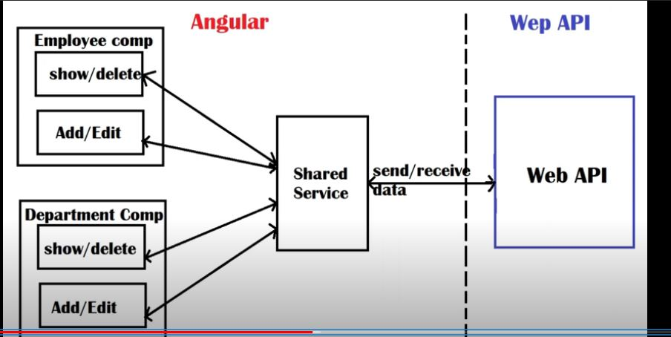

This is the structure of Angular project we make service to create http client and observable to get data from the server and handle synchronously .

**Output**

